**Sony responds to Microsoft's acquisition of Activision Blizzard by paying $3.6 billion for Bungie.**

The game sector is gradually becoming highly interesting.

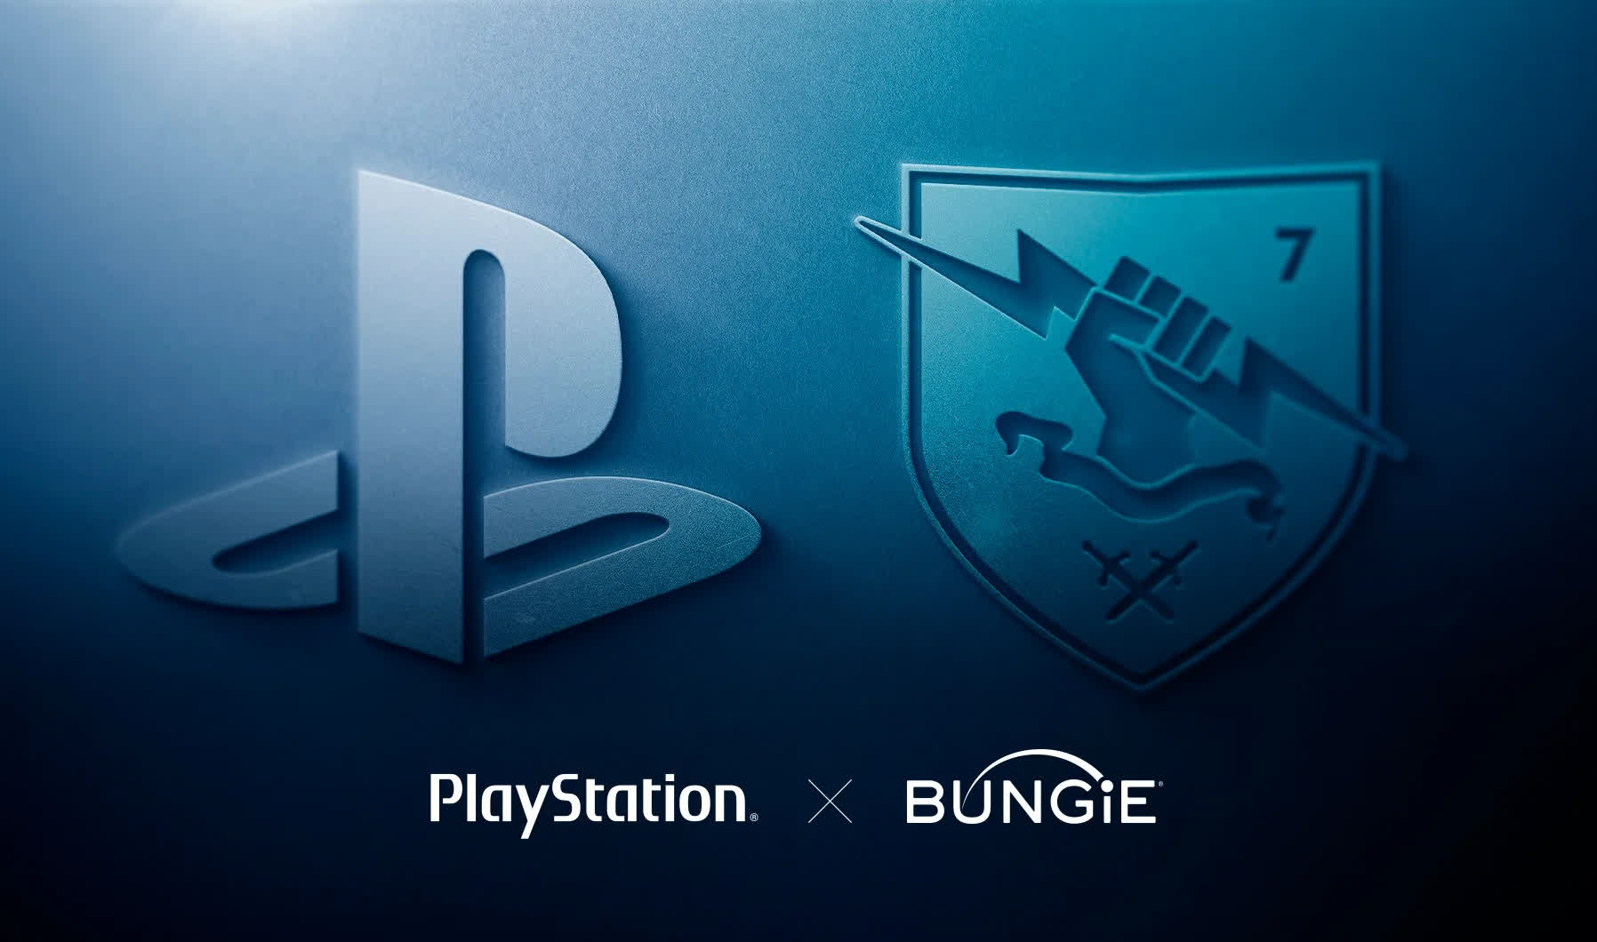

So, what exactly happened? Sony has reacted quickly to Microsoft's purchase of Activision Blizzard by agreeing to buy Bungie, the original inventor of the Halo franchise (which it has since broken ways with Microsoft) and developer of Destiny. Bungie will become an independent subsidiary of Sony Interactive after the acquisition is completed, with a board overseen by Pete Parsons, Bungie's current CEO, and the rest of the present management team.

Jim Ryan, President and CEO of Sony Interactive Entertainment, said he wanted to make it clear to the community that Bungie will remain an independent, multi-platform studio and publisher.

Bungie was formed in 1991 and bought by Microsoft in 2000, just days before Apple was about to acquire the studio, repositioning Halo: Combat Evolved as an Xbox launch title.

Bungie and Microsoft split up in 2007, although Microsoft still owns the Halo franchise. Since then, the studio has released two major instalments of the multiplayer first-person shooter title Destiny.

Bungie, which is now situated in Bellevue, Washington, and employs over 900 people, will cost Sony $3.6 billion.

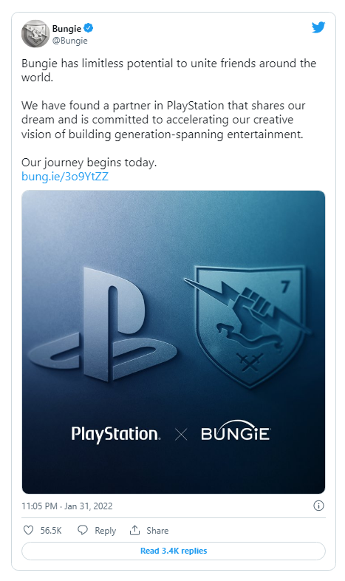

Bungie has published an FAQ on the subject, noting that its plans for Destiny 2 – including the upcoming expansion The Witch Queen – will not change as a result of the acquisition. There will be no platform exclusives, and all of the previously announced platforms will still be supported.

This is the third major gaming acquisition in January, following Take-Two Interactive’s $12.7 billion purchase of Zynga and Microsoft’s monster $68.7 billion buyout of Activision Blizzard. Sony’s deal for Bungie is tiny in comparison to the others, but could be the first of more to come.